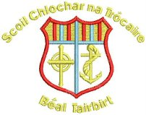
Convent of Mercy N.S.,
Belturbet,
Cavan,
Co. Cavan.
Tel:- (049) 9522992
Fax:- 049-9522961
email:- info@comns.ie
Roll No – 16057S

Admission Form 2026/2027
Please Scan Code Below



